**Carnival**

Carnival, the merrymaking and festivity that takes place in many Roman Catholic countries in the last days and hours before the [Lenten season](https://www.britannica.com/topic/Lent). The derivation of the word is uncertain, though it possibly can be traced to the [medieval](https://www.merriam-webster.com/dictionary/medieval) Latin carnem levare or carnelevarium, which means to take away or remove meat. This coincides with the fact that Carnival is the final festivity before the commencement of the [austere](https://www.merriam-webster.com/dictionary/austere) 40 days of [Lent](https://www.britannica.com/topic/Lent), during which Roman Catholics in earlier times fasted, abstained from eating meat, and followed other [ascetic](https://www.merriam-webster.com/dictionary/ascetic) practices. The historical origin of Carnival is also obscure. It possibly has its roots in a primitive [festival](https://www.britannica.com/topic/feast-religion) honouring the beginning of the new year and the rebirth of nature, though it is also possible that the beginnings of Carnival in Italy may be linked to the pagan Saturnalian festival of [ancient Rome](https://www.britannica.com/place/ancient-Rome).

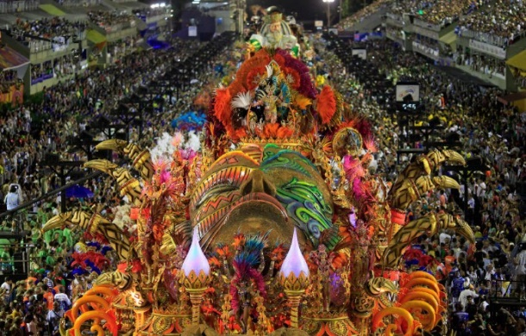

The first day of Carnival varies with both national and local traditions. Thus, in Munich in Bavaria the Carnival season, there called [Fasching](https://www.britannica.com/topic/Fasching-carnival), begins on the feast of the [Epiphany](https://www.britannica.com/topic/Epiphany) (January 6), while in [Cologne](https://www.britannica.com/place/Cologne-Germany) in the [Rhineland](https://www.britannica.com/place/Rhineland) it begins on November 11 at 11:11 AM (11th month, day, hour, and minute). In France the celebration is restricted to [Shrove Tuesday](https://www.britannica.com/topic/Shrove-Tuesday) (the Tuesday before [Ash Wednesday](https://www.britannica.com/topic/Ash-Wednesday-Christian-holy-day)) and to mi-carème (the Thursday of the third week of Lent). More generally, the commencement date is Quinquagesima Sunday (the Sunday before Ash Wednesday), and the termination is Shrove Tuesday. In some parts of Spain, [Ash Wednesday](https://www.britannica.com/topic/Ash-Wednesday-Christian-holy-day) also is included in the Carnival celebrations, an observance that stems from a time when Ash Wednesday was not an [integral](https://www.merriam-webster.com/dictionary/integral) part of Lent.

[[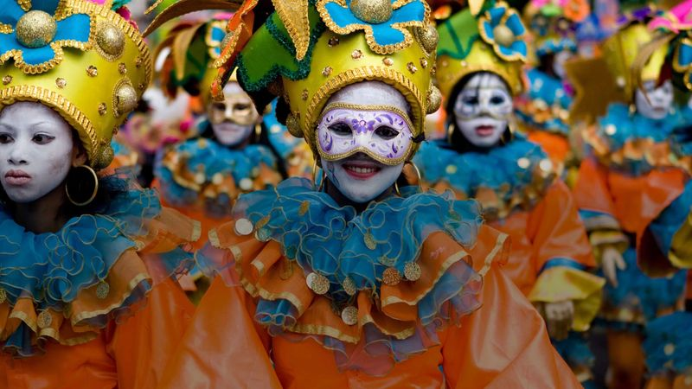](https://www.britannica.com/video/198104/Carnival-Mardi-Gras)](https://www.britannica.com/video/198104/Carnival-Mardi-Gras)

Discover the history of Carnival, also called Mardi Gras

The name Carnival might come from a Latin phrase meaning “to take away meat.”(more)

[See all videos for this article](https://www.britannica.com/topic/Carnival-pre-Lent-festival/images-videos)

In earlier times Rome was most [conspicuous](https://www.merriam-webster.com/dictionary/conspicuous) as the centre of Carnival activity, and the splendour and richness of the festivity that marked its observance there were scarcely surpassed elsewhere. Today, in a popular Carnival [parade](https://www.britannica.com/art/parade) in [Einsiedeln](https://www.britannica.com/place/Einsiedeln), Switzerland, demon masks are worn and large bells clanged to drive out evil spirits and to announce the end of winter on the eve of Lent and spring. In its long history Carnival has played a significant role in the development of popular theatre, [vernacular](https://www.merriam-webster.com/dictionary/vernacular) song, and folk dances.